1. **If U = {1, 3, 5, 7, 9, 11, 13}, then which of the following are subsets of U.**  
   *B = {2, 4}* **FALSE**  
   *A = {0}*  **FALSE**  
   *C = {1, 9, 5, 13}*  **TRUE**  
   *D = {5, 11, 1}*  **TRUE**  
   *E = {13, 7, 9, 11, 5, 3, 1}*  **TRUE**  
   *F = {2, 3, 4, 5}*  **FALSE**
2. **Let A = {a, b, d, e}, B = {b, c, e, f} and C = {d, e, f, g}**
3. *Verify A ∩ (B ∪ C) = (A ∩ B) ∪ (A ∩ C)*

= A ∩ (B ∪ C)

B ∪ C = {b, c, d, e, f, g}

A ∩ (B ∪ C) = {b, d, e}

&

= (A ∩ B) ∪ (A ∩ C)

A ∩ B = {b, e}

A ∩ C = {d, e}

(A ∩ B) ∪ (A ∩ C) = {b, d, e}

A ∩ (B ∪ C) = (A ∩ B) ∪ (A ∩ C) Verified

1. *Verify A ∪ (B ∩ C) = (A ∪ B) ∩ (A ∪ C)*

= A ∪ (B ∩ C)

B ∩ C = {e, f}

A ∪ (B ∩ C) = {a, b, d, e, f}

&

= (A ∪ B) ∩ (A ∪ C)

A∪B = {a, b, c, d, e, f}

A∪C = {a, b, d, e, f, g}

(A ∪ B) ∩ (A ∪ C) = {a, b, d, e, f}

A ∪ (B ∩ C) = (A ∪ B) ∩ (A ∪ C) Verified

1. Out of 50 students of class, 25 students liked to play football, 35 liked to play basketball and 15 liked to play both the games. How many students do not like to play any games? Show the above information in a Venn-diagram.

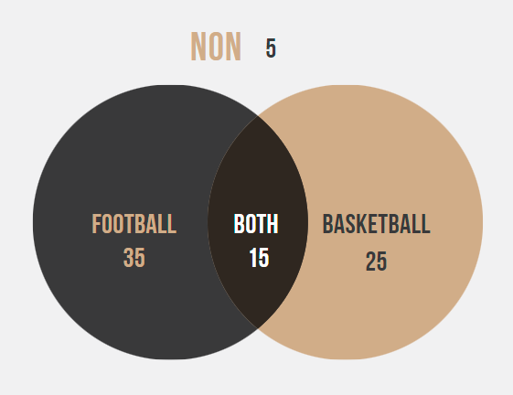

1. 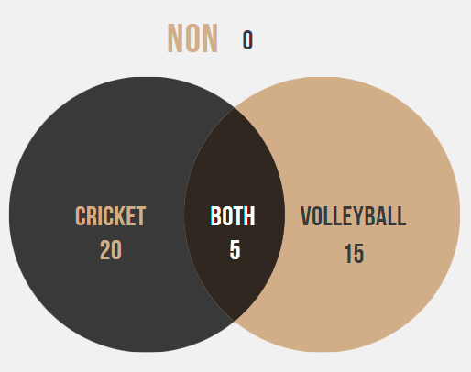In a class of 30 students, 20 students like to play cricket and 15 like to play volleyball. Also, each student like to play at least one of the two games. How many students like to play both games? Illustrate the above information in a Venn-diagram
2. In a group of 100 people, 72 can speak Dhivehi and 43 can speak English. How many can speak Dhivehi only? How many can speak English only and how many can speak both English and Dhivehi?

**57**

1. Out of 100 students, 80 passed science, 71 mathematics, 10 failed both subjects and 7 did not appear in the examination. Find the number of students who passed both subjects by representing the above information in a Venn-diagram.

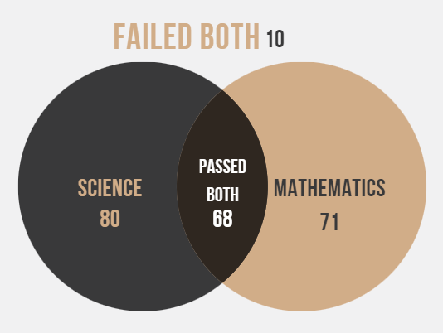

1. Out of 150 college freshmen were interviewed,85 were registered for a Math class,70 were registered for an English class,50 were registered for both Math and English.
2. How many signed up only for a Math Class?

**35**  
b) How many signed up only for an English Class?

**20**  
c) How many signed up for Math or English?

**85 or 75**  
d) How many signed up neither for Math nor English?

**45**

1. If P and Q are two sets such that P ∪ Q has 40 elements, P has 22 elements and Q has 28 elements, how many elements does P ∩ Q have?

**10**

1. It was found that out of 45 girls, 10 joined singing but not dancing and 24 joined singing. How many joined dancing but not singing? How many joined both?

**21**